ETV Trinity ’07 Entrepreneur Interview :

Tim Westergren, Pandora.com

I hereby certify that the following piece of work complies with the Own Work Declaration form already issued and with the University’s Rules and Regulations relating to plagiarism and collusion, as listed in the Essential Information for Students and the MBA Course Handbook.

Student ID: 8268

Introduction
Tim Westergren is founder and CEO of Pandora.com, an internet based music recommendation and radio service. I will conduct a R.A.C.E. framework analysis of Pandora chronologically, as R.A.C.E elements map well to clearly definable periods of Pandora’s history.

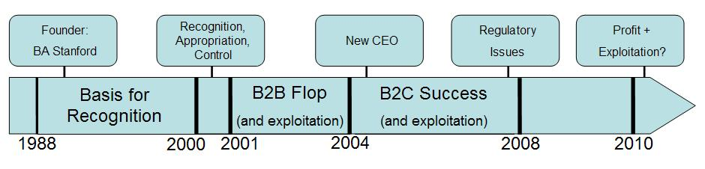
Pandora Timeline 1988 - Present

I have divided my report into 4 phases: (1) A Basis For Recognition, (2) Recognition, Appropriation and Control, (3) B2B Flop and Exploitation, and (4) B2C Success and Exploitation. Regardless of recent media attention, I treat Pandora’s recent regulatory conflict as a sub component of it’s B2C phase.

Despite travelling extensively for business and in support of a grass roots campaign to reverse regulatory rulings by the US Copyright Royalty Board, Tim was kind enough to take an hour to speak with me from his London hotel room. I wish to express my gratitude to him, and to Michele Husak, Director of Communications at Pandora, for their support in facilitating this interview. All quotations are taken from my phone interview with Tim Westergren, 19.05.07, unless otherwise noted.

Technical and Business Model

How Pandora Works
Pandora is a website that allows users to create and listen to multiple personalized internet radio stations. Users create stations by searching for songs or artists they like in the Pandora database. If found, Pandora uses the Music Genome Project (hereafter MGP) to find similar songs and artists, which are then played over the personalized station. As a user listens to a station, they are able to rate each song positively by clicking a “thumbs up” icon, or negatively by clicking a “thumbs down” icon. This data is then used to refine the list of songs from which the MGP chooses subsequent songs for the user. In this manner, a user is able to find new music similar to their existing tastes, gaining exposure to unknown artists and major recording stars equally… an impossibility in traditional radio.

How MGP Works
The MGP relies on a genre specific “genome” of several hundred song characteristics (genes) to classify a given song. Examples of genes would include Blues Roots, Gravely Female Vocalist, Grunge Recording Qualities or Flat Out Funky Grooves. Musical experts employed at the MGP listen to each song for 20 to 30 minutes to determine each gene of the song on a scale of 1 to 5. The ‘genotypes’ of songs a user rates favourably are used to calculate a user preferences vector. This vector is used to query the MGP for a ranked list of song recommendations.

How Pandora Makes Money
Pandora has two user based revenue streams: ad supported, and ad-free subscriptions for $36/year.

History

Phase 1: A Basis For Recognition (1988 – 2000)
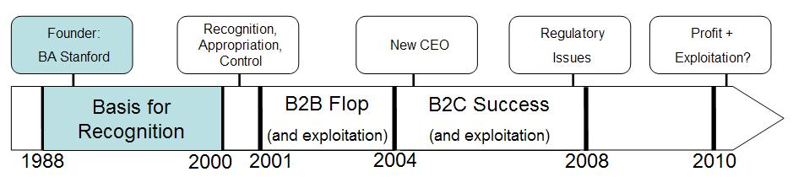
The Pandora and MGP concepts ultimately arose out of Westergren’s passion for music and musicians, and his experience using a technical tool of the film composer’s trade.

Westergren’s background in the field extends at the very least to 1988, when he received his BA in Computer Acoustics and Recording Technology from Stanford University. Following this, his career included stints as a musician, recording artist, producer, and studio owner, providing him with experience in the field and a deep respect for musicians. Later in this phase, he worked as a film composer. The technical process by which film composers identify suitable music for a score provided the basis for what would later become the MGP: iteratively swapping songs (mixed tapes, CDs, online, etc.), getting feedback, picking new songs based on relatedness, and swapping again. After several rounds of this, a composer is able narrow down and “glean the tastes” of a director. The experiences of this phase gave him the background necessary to recognize the Pandora opportunity.

Phase 2: Recognition, Appropriation, and Control (2000)
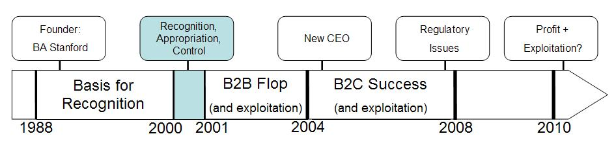
In 2000, Westergren’s motivations for starting a new business solidified, instigating conversations with a B-School educated friend on how to start a business, ultimately resulting in the technical and cultural establishment of Pandora, and a first round of funding.

Westergren recognized that a resource such as the MGP, combined with a delivery mechanism, could “transform the music business” by giving listeners a new way to discover new music, and “support the rise of a musician middle class” by giving independent musicians a means of getting their music to a much wider audience. These motivations formed the basis for Pandora. Further noting the “all time low” of relationships between music fans and record labels, Westergren recognized a need and opportunity to build positive relationships between music fans and his business.

Conversations with college friend John Kraft (MBA, Stanford Technology Group, Clone Interactive) convinced Westergren of the need to more fully recognize the opportunity via a formal business plan. These conversations also let to the appropriation of Kraft as a starter CEO. As founder of the Stanford Technology Group (sold to Informix in 1995), Kraft brought tested entrepreneurial experience to the team.

Establishing Pandora, the MGP, and filing patents on it’s technology, Westergren exerted control over Pandora’s intellectual property. However, the value of this IP should not be overestimated. Per Westergren, the algorithms are “not complex”, and the notion of services which relate songs to one another is not unique. According to Westergren, Pandora’s significant sources of competitive advantage lie in its culture, its first mover status, and its constantly growing database of user preferences, not in irreproducible technical innovations. In Westergren’s opinion, “the best investors invest in people, and an idea in the broadest sense, not a business model”, and this view runs parallel to his view on staffing. The most critical component he seeks in new staff is not exact fit to role, but rather intelligence, work ethic, and above all respect for musicians. The latter element he holds as Pandora’s “most holy tenet”, reflecting his personal attitudes toward musicians. However, Westergren also stresses the importance of positive relationships with users in the Pandora culture. By selecting new hires that are predisposed to these values, Pandora’s staffing strategy helps to maintain control through internal culture as the business scales up.

A first round of investment was secured in March 2000. Working through personal networks to locate prominent investors such as Guy Kawasaki (garage.com) and John Rogers (Rogers Investment Group), Pandora appropriated an initial infusion of what would shortly become their most difficult to obtain resource: cash. Within the month, the dotcom bust would make any hope of further cash infusions hopelessly remote.

Phase 3: B2B Flop and Exploitation (2000 – 2004)
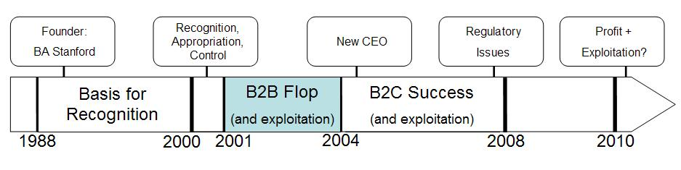
The first four years of Pandora’s existence provided few opportunities for exploitation. Initial plans of licensing their technology to retail outlets, Yahoo! music, and other B2B customers proved unprofitable, resulting in a dismal two year period during which salaries went unpaid. Westergren states with some degree of lingering incredulity that he “finally managed to find” a second infusion of cash In 2004. This appropriation was followed shortly by a change of CEO, ending what I have termed the ‘B2B flop’ period.

Phase 4: B2C Success and Exploitation (2004 – present)
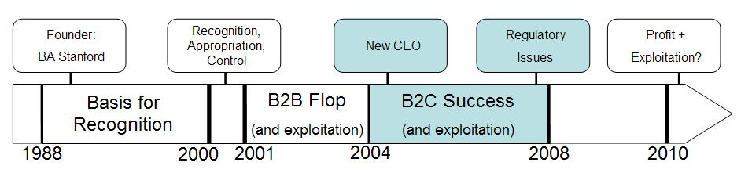
Following the 2nd cash infusion and a subsequent strategy change, Pandora experienced growth, regulatory challenges, and a massive show of user support via a grassroots political campaign. Yet, prospects of exploitation remain elusive.

The new CEO, Joe Kennedy (eLoans, Saturn), began his tenure by leading the executive team through a strategy review. Because of the wider availability of broadband, a business model based on streaming audio to home users became feasible. Pandora switched to a B2C model, thus removing the barrier to exploitation posed by the failing B2B model. This also presented Pandora with an opportunity to fill a void that the existing music industry could not or would not fill, by creating a direct and positive relationship with consumers. The period of 2004-2007 saw the rise of Pandora to prominence in the online broadcasting industry, building up a user base of ~7 million, a station count of ~50 million, and a DNA catalogued song count in excess of 500,000. While still not profitable, Westergren foresees profitability for Pandora within the next two years… exploitation is finally within the realm of possibility.

With regard to plans for harvesting value, Westergren states that "a misperception about businesses is that they actually have a plan", and that he is “not a big believer in strategy being based on a fixed and known path”. With profitability still in the distance, it may be premature for Pandora to consider exploitation, particularly in light of recent regulatory challenges. A great deal has been written recently about the US Copyright Royalty Board (hereafter CRB), and its recent ruling regarding internet broadcasters. However, the practical effect of recent rulings, if upheld, would be to charge Pandora ~$5 Billion per year in royalties! Vastly exceeding revenues, this measure would force the immediate closure of Pandora.

Banding together with other internet broadcasters, Pandora has spearheaded a campaign to persuade the US Congress to overturn the ruling. With support from 7 million Pandora users and 60 congressmen, emergency legislation has been introduced by senators to temporarily block the ruling. With broader congressional backing, this change may become permanent. Westergren ties this massive outpouring of support to Pandora’s positive relationships with users and reverent treatment of musicians. He observes that a similar attempt to gain support for a major record label at this point in time would be almost unthinkable. The final outcome of this most recent barrier to exploitation remains to be seen.

Lessons Across the RACE Framework
From the perspective of recognition, there are several key lessons from the Pandora case. Firstly, processes specific to a certain audience or field, such as film score song swapping, may be successfully repurposed to a larger audience in a different field. Secondly, deep experience in a given field, such as Westergren’s experience in the music business, is of value when forming a venture to address that business. Thirdly, an industry with a poor relationship with its customers may present an opportunity for recognition by a new player.

With regard to appropriation, the key lessons from the Pandora story are that personal networks are viable means of securing funding, and also that depending on business cycles, funding may be relatively more or less feasible.

Another lesson gained from Pandora is that while some degree of control may be achieved by securing IP through structural means (patents), it may not be meaningful without other controlling factors. Pandora’s strong requirements with regard to the character of new hires allow for maintenance of their critical user and musician centric culture through selection. This factor has clearly played a role in recent regulatory conflicts.

According to Westergren, exploitation may not be an immediate strategic consideration in every business. In my view, this is reasonable given his analysis of business strategy as an emergent phenomenon. However, I cannot rule out the possibility that this is also reflective of Pandora’s current place in the business lifecycle: they simply aren’t at a point where exploiting the investment is a possibility.

Elements Unique to Internet Radio Entrepreneurship
Despite the technology, patents, regulatory issues, etc., Westergren views the high degree of personal connection with users to be the unique element of entrepreneurship in Pandora’s field. He feels that Pandora’s passion for music and musicians resonates with their customers, generating personal connection, and thus, loyalty. The positive aspects of this may be seen in the massive support recently demonstrated by Pandora’s user base. However, this connection represents a double edged sword: personal connections may turn bitter. Westergren highlights this in the plight of US record labels. He feels that consumers have the impression that record labels don’t care about musicians, music or consumers. Therefore consumers don’t care about labels, and have no issue with stealing music via file-sharing. In reaction, labels sue their own customers, generating greater animosity and thereby feeding a vicious circle. Westergren summarizes this bleakly: “nobody gives a shit about file-sharing, because no one cares about record labels… because record labels don't care [about consumers] and it shows”.

Conclusion
Despite Pandora’s innovative technical concept and recent tenure in the political spotlight, it presents a classic story of entrepreneurship: an innovator learns a skill in one field, recognizes its applicability to another, and appropriates resources to launch a venture, controlling the venture via organizational culture. The most interesting element of this story is that Pandora’s culture has given rise to customers who care so deeply about it. One must wonder if Pandora’s ultra-supportive customer base derives strictly from their customer and musician centric culture, or if this level of customer loyalty is an artefact of the Web2.0 sphere, where users invest in and identify strongly with the services they use. Perhaps one day this level of customer loyalty will also become a classic story.

Appendix 1: General Sources
Pandora corporate website: http://www.pandora.com/corporate/team

Wikipedia articles:
http://en.wikipedia.org/wiki/Music_Genome_Project, http://en.wikipedia.org/wiki/Pandora_%28music_service%29

Phone Interview: Tim Westergren, 19.05.07

Recognize, Appropriate, Control, Exploit
Westergren refers to the rise of file sharing and subsequent record label initiated lawsuits against customers as evidence of the “broken-ness” of the industry.
Itunes, last.fm, Ilike, etc.
Anxious Times for Internet Radio, The Wall Street Journal, March 12, 2007; Music Radio On The Internet Faces Thorny Royalty Issues, The New York Times, May 14, 2007; Web Radio Stations Sing the Blues to Congress, The Washington Post, May 19, 2007
i.e. file sharing, lawsuits against customers, “broken-ness”, etc.

